This series of power supplies incorporate the high frequency switch mode technology to give highly regulated panel mountable portable units with kV range varying from 10Kv to 60kV catering to a wide variety of scientific and industrial applications. All controls & displays are detachable for external operation from panel.
REGULATED HIGH VOLTAGE POWER SUPPLY
10kV to 60kV, 400µA

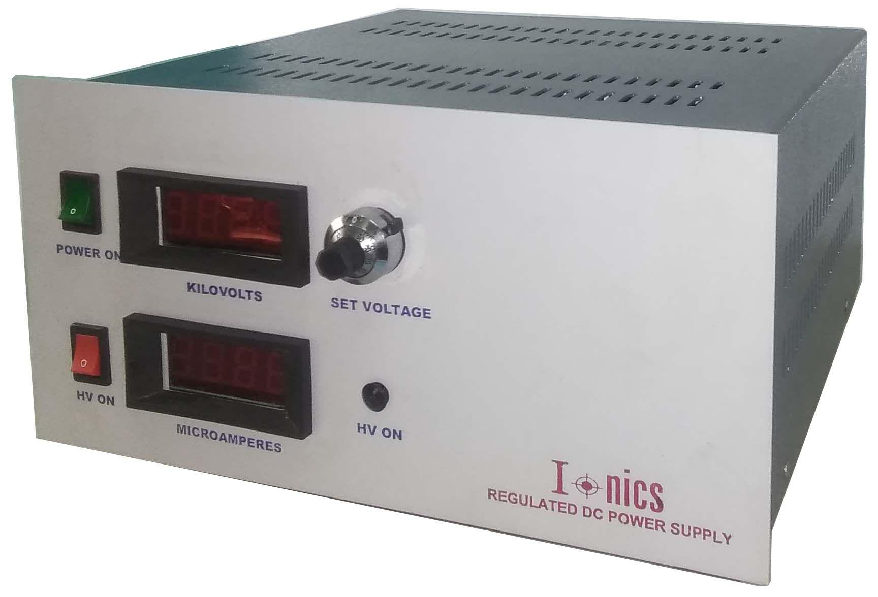
Features:
- Compact & Modular
- Precision Regulated
- High stability
- Remote operation

Technical Specifications
PARAMETER | SPECIFICATION
Input voltage* | 115V or 230V± 10% AC, 50Hz, single phase
Output Voltage* | 0 to 10/20/30/40/50/60kV DC
Output Current | 0 to 400µA / 1mA
Polarity * | Positive / Negative
Line Regulation | <0.05% for±10% variation in input voltage
Load Regulation | <0.05% for 10 to 100%load variation
Stability | <0.01%hour after 1 hour warm up
Regulating Mode | Constant voltage
Voltage control  (From zero to rated kV) | By external 10-turn potentiometer with lockable counting dial
Protections | Against overload, arc and short-circuit  During short circuit, power supply trips & to be manually reset to restart
Front Panel | 25pin D-connector for external operation Series I  9pin D-connector for remote control  25pin D-connector for external operation Series II  Power ON/OFF switch  HV ON/OFF switch with indication  3½ digit voltage and current meters Series III  10-turn potentiometers for voltage and current control  Constant voltage – constant current mode indication  LED indications for faults
Back Panel | 10pin terminal block  Fuse holder with fuse  RF connector for HV output  Stud for grounding the unit
Topology | High frequency switch mode
Size | 10” x 10” x 5” (W x D x H)
Output cable | 1.5meters of HV DC cable
- OEM Customization available
*Optional. To be specified by the user.

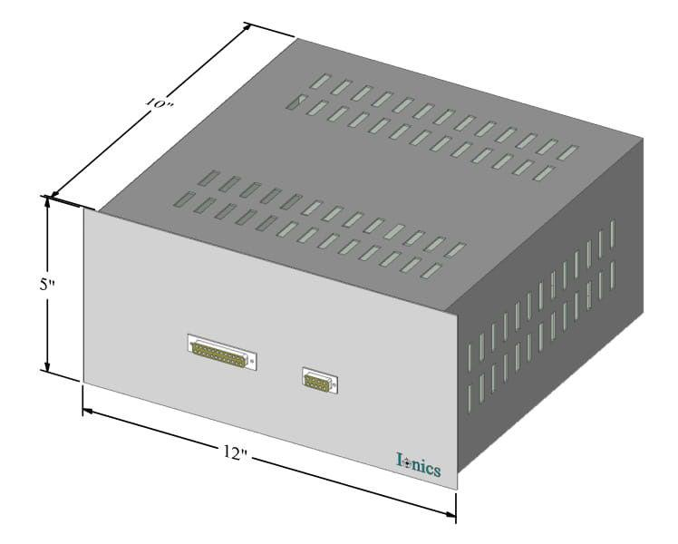
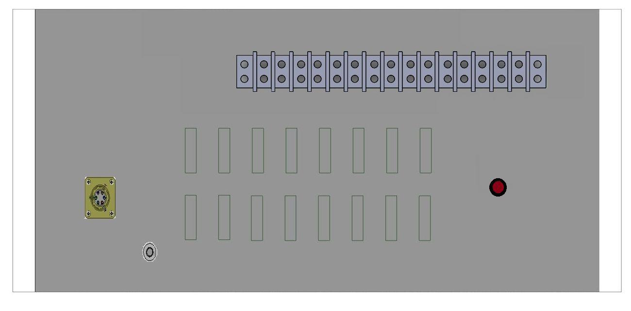
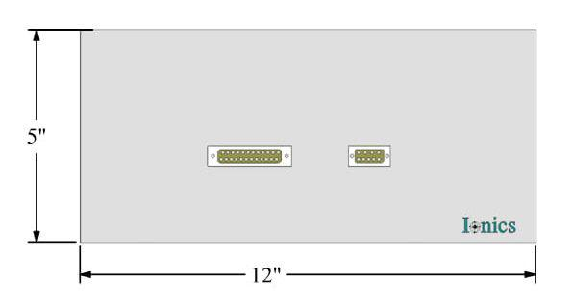
Series-1

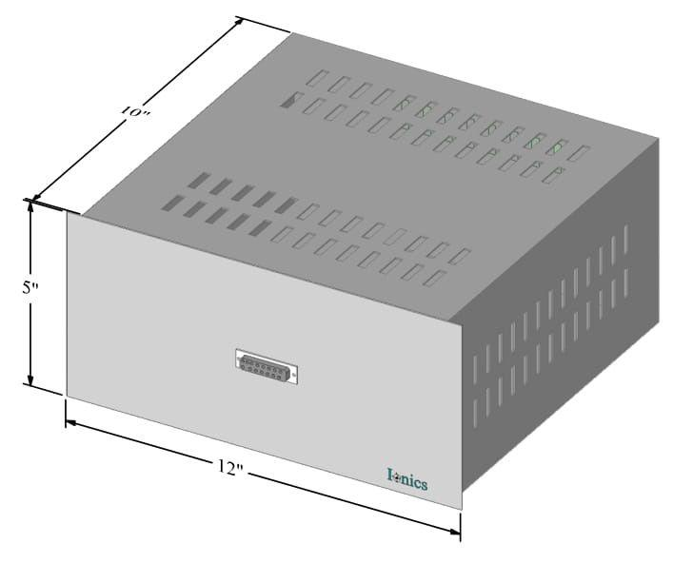
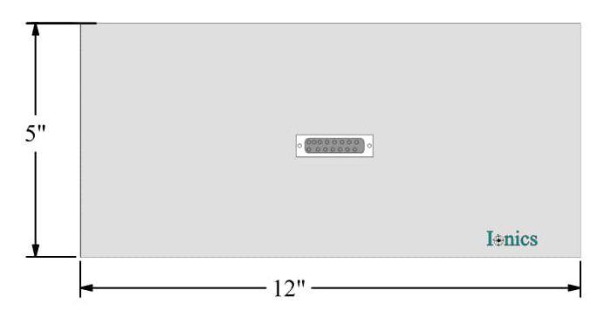
Series-2

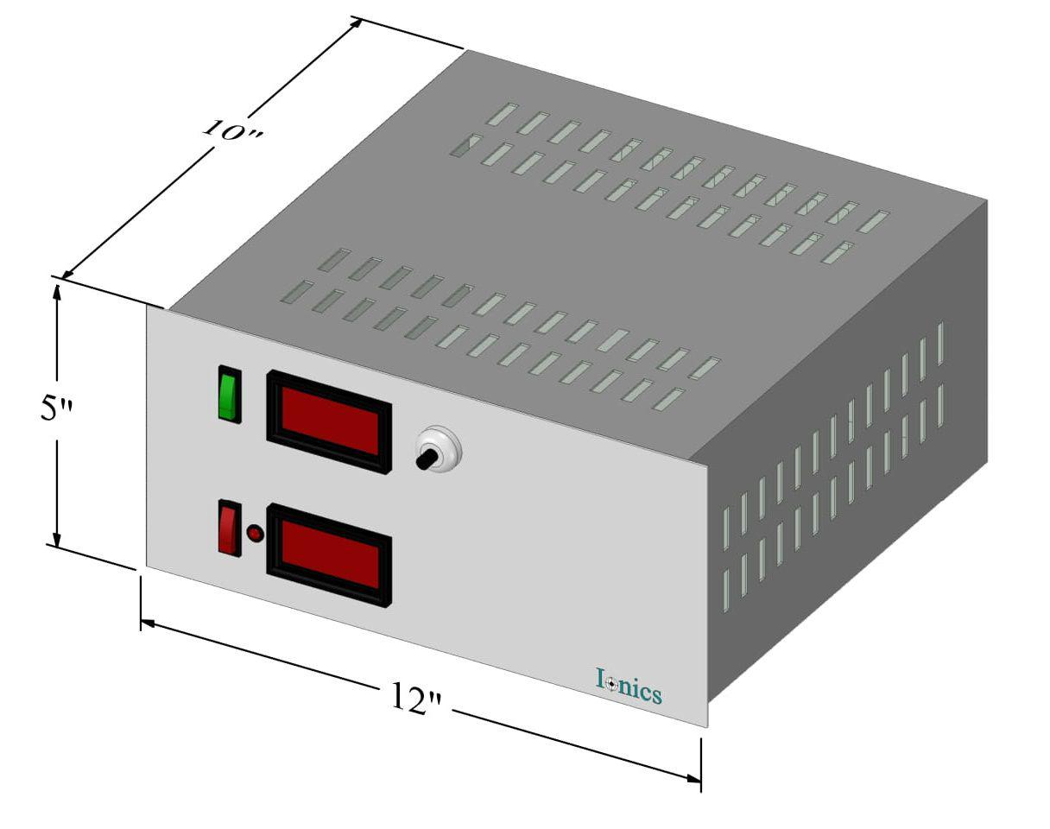

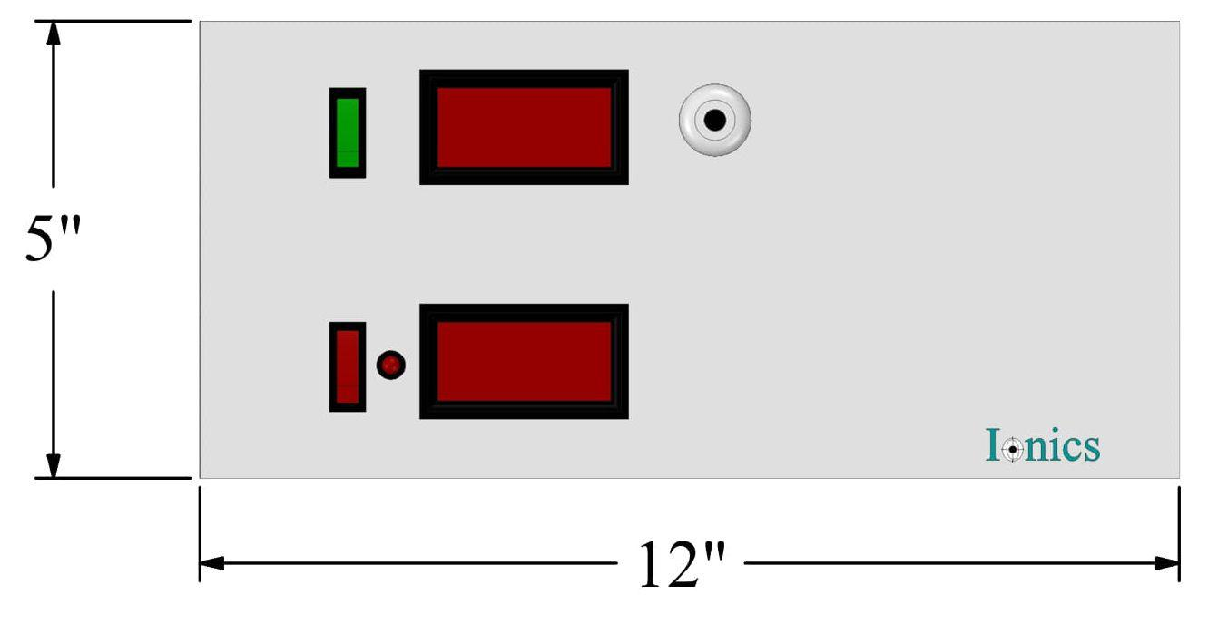
Series-3

Ordering  Code | MF | 050 | K | 020 | W | P | C | U | D | 4 | L
 |  | 1 |  | 2 |  | 3
Section | Description |  |  | Options |  | Options Description
1 | Output Voltage |  |  | XX |  | Value of output voltage  XX=10/20/30/40/50/60:  For 10/20/30/40/50/60kV
2 | Output Power |  |  | YY |  | Value of output power (XX x 400µA)  YY=04/08/12/16/20/24;  for 4/8/12/16/20/24W
3 | Polarity |  |  | P |  | Positive
 |  |  |  | N |  | Negative

For any queries or customization requests contact us at info@ionics.co.in
For product line information visit us at www.ionics.co.in

